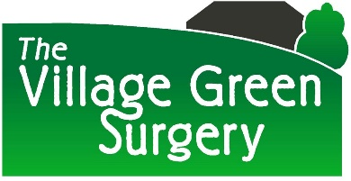 Private Fees list (Non NHS Work, June 2025)
To Whom It May Concern Letter (simple short letter including regarding housing) | £30
Detailed letter Requests | £100
Holiday insurance / sickness insurance form | £50
Life / critical illness Insurance Medical reports | £100
Solicitor report with Examination | £150
Solicitor report without examination | £100
Police medical History Form | £85
Childminder OFSTED Health Declaration | £85
Pre employment medical with examination | £100
Occupational Health Reports | £100
Taxi Driver Medical | £100
HGV or PSV (PCV) Medical | £110
Certificate of fitness to drive | £100
Firearms Certificate | £60
Fitness to Travel Letter | £50
Private Prescriptions | £15
Private Sick Note | £30
Private Consultation | £50 per consultation
Assessment of capacity | £150
Sports Medical | £90
Fitness to participate in Activity | £40
Camp America Forms | £40 without examination £90 with examination
Private blood tests | £50 appointment fee + fee for tests available on request (blood group testing not offered)
Free from infection forms | £50
Passport Photo verification | Not completed
Driving licence Photo | Not completed
The above list is not exhaustive. If you require a form which does not appear on this list please provide a copy to reception and we can advise on cost if we are able to complete.
Payment will be taken at time of form request. Payment is required prior to appointment for private medical examinations. Refunds will not be offered in the case of dissatisfaction with the professional opinion / judgement of the Doctor.
Fees are reviewed annually.

